Mungo...  The Port Phillip Citizens for Reconciliation  respectfully acknowledge the Traditional Owners  and Custodians of the land on which we meet, and  we pay our respects to their Elders; past, present  and emerging. | 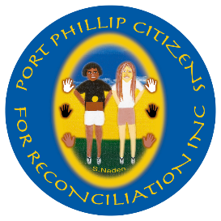  Port Phillip Citizens for Reconciliation Inc.  ABN: 44416152998  P.O. Box 1446 .  St Kilda South VIC 3182  Phone: (03) 9699 8804  Mobile: 0418 675734  Email: rosemary.rule@gmail.com  www.ppcfr.org
This newsletter is supported by a Community Grant from the City of Port Phillip.

October 2024
AGM 15th October  Come along to our AGM on 15th October and meet guest speaker, proud Aboriginal man of Tasmanian descent, Charles Pakana (born Keir Wells). He’s the second of three generations of Aboriginal journalists and founder of Victorian Aboriginal News (VAN) which produces digital content focused on truth, treaty and reconciliation across Victoria. VAN content features the VAN Talks podcast and VAN Leader Tapes video series. Uncle Charles is also a regular on 3KND, producing and hosting the Victorian Aboriginal News Hour. |  | 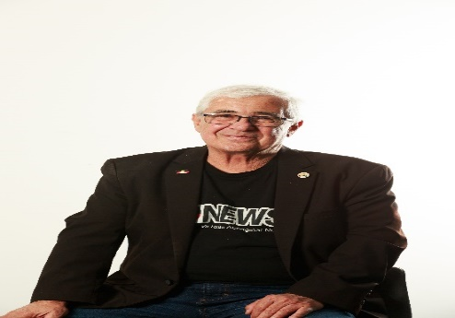
We will also elect our office bearers: currently Co-Chairs Dennis Fisher and myself; Treasurer Fiona Olney-Fraser, Secretary Deb Stewart, Ordinary Members Jo Bond, Joy Bandy, Fiona Darroch-Green. Refreshments afterwards. A Proxy Form is attached if you can’t attend.
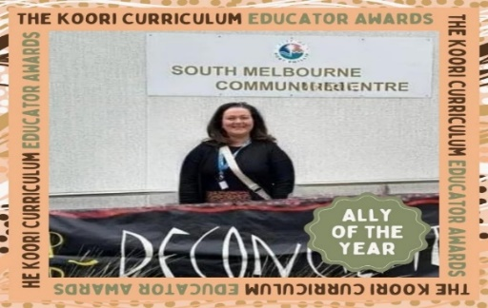  Koori curriculum educator Ally of the year Narelle Cahill, attending our sorry day lunch.  Next meeting: Tuesday, 15th October 6.00pm,  South Melbourne Community Centre, Hall 3, Ferrars Place, (off Park Street) South Melbourne. All welcome. Enquiries: 0418 675 734. | Congratulations To Uncle Shane Charles, appointed First Peoples Advisory Lead at Brimbank Council.  To former Northern Territory health minster Selena Uibo, named as the new leader of the NT Labor Party and first Indigenous woman to lead a major political party in Australian history,  To Narelle Cahill, Quality Improvement Manager, Astra Education, The Koori Curriculum Educator Ally of the Year. “Narrelle has played a pivotal role in embedding Aboriginal perspectives across our six early years services, demonstrating a deep passion for fostering a Culturally inclusive environment,” her citation noted. “Through her dedication to continuous professional development, Narrelle has deepened our staff's understanding of Aboriginal culture.” (Port Phillip Citizens for Reconciliation has a good working relationship with Astra’s Bay Street, Port Melbourne Centre).  Rosemary Rule Co-Chair

NGARGEE TREE DAMAGED  The culturally significant Ngargee Tree, located at St Kilda Junction, was damaged in recent high windstorms, loosing many branches. Some of the larger pieces remain on the site and being managed by Parks Victoria. The Port Phillip Council alerted the Bunurong and Boonwurrung Traditional Owners who collected smaller pieces to safeguard and are continuing to work with Parks Victoria to find ways to restore the site. The Ngargee Tree is an ancient red gum that holds deep history and cultural significance to the Bunurong people | 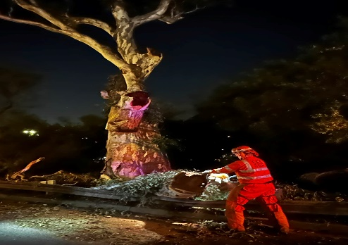  Storm damaged Ngargee Tree
WAMBA WAMBA  The Wamba Wemba Aboriginal Corporation (WWAC) has been officially recognised as Victoria's 12th Registered Aboriginal Party. WWAC Chair Lowana Moore was also recently appointed as the Corporation’s representative on the First Peoples’ Assembly of Victoria.  FIRST NATIONS CLEAN ENERGY  Australia’s first First Nations owned energy retail company, Yurringa Energy, will provide electricity to build Victoria’s biggest road project, delivering 100% renewable power during the construction of the North East Link tunnels, and 137.5 GWh of renewable electricity, the equivalent of more than 91,000 solar panels producing power over a year. This FN-owned company was chosen following a competitive tendering process and will contribute to social procurement outcomes being achieved across state-shaping projects like North East Link. The renewable energy will be used to power large site compounds for the project, and the massive tunnel boring machines, soon starting to dig the 6.5 km road tunnels from Watsonia to Bulleen. Yurringa Energy founder Daniel Briggs says the contract is the first for the new business dedicated to creating employment opportunities for First Nations people. | RECONCILIATION VICTORIA NEWS  Speakers at RV’s Local Reconciliation Group State-wide forum on 5 October at T.O.M.S Place, 1 Tripovich Street, Brunswick, include RV’s Co-Chair Professor Andrew Gunstone, Interim CEO Alistair King and MC, Uncle Charles Pakana, founder and editor of Victorian Aboriginal News. Bookings essential: reconciliationvic.org.au. Reconciliation Victoria and ANTaR Victoria’s annual forum and AGM is being held on 26 October, 10:45am-3:00pm at Djerring Flemington Hub, 25 Mt Alexander Rd, Flemington. Registration essential: https://events.humanitix.com/annual-forum-and-agm-2024-reconciliationvictoria-antarvictoria.  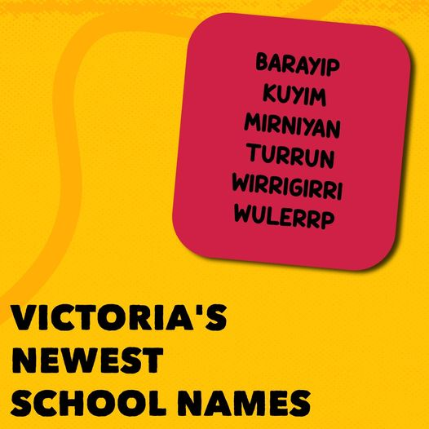  The names of these six new schools, provided by the Bunurong and Wurundjeri Woi Wurrung people, reflect their local place for Barayip Primary School in Tarneit; Kuyim Primary School in Pakenham; Mirniyan Primary School in Clyde North; Turrun Primary School.l in Clyde North; Wirrigirri Primary School in Wollert; and Wulerrp Secondary College in Clyde North.

A REMARKABLE STORY ABOUT THE KULIN PEOPLE – Book Review by Sue Taffe
The Years of Terror, Banbu-Deen: Kulin and Colonists at Port Phillip 1835-1851
Marguerita Stephens with Fay Stewart Muir, Australian Scholarly Publishing, 2023.
This book is a remarkable achievement. While other histories have been written of this period, this is the first to provide readers with a detailed narrative of the events experienced by the Kulin people following the spurious Batman treaty in 1835. Fay Stewart-Muir, Boonwurrung Elder, explains in the Preface that the writer has collaborated with present-day Woiwurrung and Boonwurrung custodians in her meticulous research. Fay comments that she has learned much about her ancestors through Marg’s work.
What makes this history so different is the expression of the full range of human emotions and ideas about what is happening to the Kulin people. We become involved with Billibellary, Benbow, and many others. We see the injustices they face. Once a fence is erected by a settler, they cannot strip bark within it for their willums, nor can they hunt or harvest their traditional foods.
We experience with Thomas and the Kulin the cultural misunderstandings on both sides and the underlying assumptions contributing to these misunderstandings. Tromgin (now within the Royal Botanical Gardens) was a traditional gathering ground for ceremonial purposes. With the arrival of white settlers, Superintendent Latrobe, while privately acknowledging the Kulin’s right to ‘wander over the pastoral districts,’ instructed Thomas to get the Kulin out of Melbourne. The people ask Thomas ‘where are we to go’ and beg him to ‘get us a country.’ While Thomas attempts to meet their needs, he fails to understand their reluctance to settle in one place and cultivate the soil. Nor can he understand their attachment to their own spiritual belief system instead of embracing Christianity as he hoped they would.
Kulin experienced a British justice system prejudiced against them. Because Aboriginal evidence was inadmissible in court in cases of violent clashes between Aboriginal groups and pastoralists, the latter were rarely charged. When two whalers were murdered by Truganina’s party in 1841, the guilty men, Tunnerminnerwail and Maulboyheener, were publicly hanged in Melbourne with 3000 of 5000 settlers attending. Two years later, three pastoralists were tried in Melbourne for the murder of four women and a boy in an incident referred to as ‘the Lubra Creek massacre.’ Governor Gipps referred to the incident as an ‘atrocious murder,’ but the jury acquitted the men
The effect of reading this history for me was akin to watching a Greek tragedy. We meet a people with a strong relationship to their land, developed hunting and harvesting skills, a social system structuring human relationships, and a cosmology helping them understand their world. The white invasion, initially illegal in British terms but sanctioned when Governor Bourke persuaded the imperial government to support a new settlement at Port Phillip, challenged every part of their world. The newcomers saw land as an economic commodity.
Diseases previously unknown to the original inhabitants, such as tuberculosis and influenza, ravaged the population. People could no longer hunt successfully; sheep and cattle trampled the valuable Murnong daisy. The Kulin realized they had lost their land. They were hounded out of Melbourne and off pastoral stations. Starvation also contributed to deaths, and people were no longer confident about bringing children into their ruptured world. While Thomas did his best to help the Kulin settle in one place and preached against violent feuding within the tribes, attachments to their old world remained, making adaptation difficult. Meanwhile, the numbers dwindled, with Thomas reporting that by 1848, thirteen years after white settlement, the Boonwurrung and Wurundjeri populations had declined more than sixty percent from tuberculosis, influenza, venereal diseases, and starvation.
Prime Minister Albanese has spoken of the importance of truth-telling about our history. We might question exactly what that means. Whose truth? Is there only one? Perhaps a more useful approach is to encourage all Australians to recognise and be prepared to share their histories. Not all settlers were brutal. Aboriginal warriors also committed violent acts sometimes against innocent individuals. A black and white approach is of no value when we are trying to understand a society which existed 170 years ago and was very different to today. Acknowledgement of the suffering of others in an unequal power struggle is, however, surely a prerequisite in any question for cultural cohesion. This is a ‘must read’ for Australians interested in this question.

ART  Aboriginal and Torres Strait Islander student artists from Swinburne University in partnership with Moondani Toombadool Centre and Swinburne Student Life. Boroondara Arts showcase works from the Swinburne 2024 annual NAIDOC Design Competition, Hawthorn Arts Centre, until Sunday 10 November.  Future Dreaming: 250 artworks created by First Nations artists incarcerated in Victorian prisons in 2024. Each has created an artwork that explores their concept of “Future Dreaming.”  The Torch Gallery, 146 Elgin Street, Carlton, 25 Ocober-20 November.  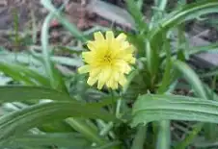  Murnong Daisy  WOMINJEKA GARDEN WORKSHOP  A workshop guided by Dean Stewart about the original plants from the area utilising some of the edible plants relating to planning the Wominjeka garden at the new EcoCentre. A Wemba Wemba-Wergaia man with over 25 years’ experience, Dean co-ordinates and conducts Cultural Education, tourism, conservation and interpretation programs and created the ‘Once As It Was’ mapping projects for Port Phillip council.  EcoCentre Botanist/Friday Garden Group coordinator, Peter Kelly, will talk about the role local plants play and conduct a cooking demo. Eco Centre, 30 Blessington Street, St Kilda, 10:00-12:00, October 25. Register 9534 0670; info@ecocentre.com. | BOOKS  ‘Always Was Always Will Be’ by Thomas Mayo. At the Wheeler Centre’s launch of his book, Thomas was defiant - and hopeful. He said: “We need to build a resilience to the discomfort we feel when we discuss political matters, then we can talk with our friends and family about matters that we believe are important for our whole country. I say we should use hope and resilience to build a fire in our bellies. We should temper our anger, hone the edge of our rage into a key that will open hearts and minds, rather than a blade that will sever our support. Those walking with us must find our energy and give hope to others.” Highly recommended.  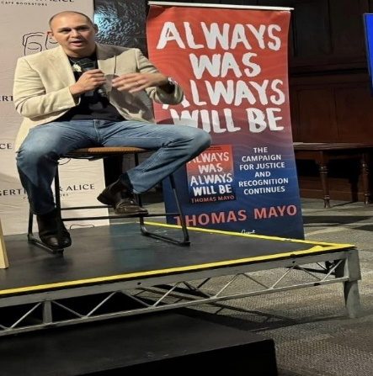  MUSIC  Noongar artist Bumpy premiers new work at Melbourne International Jazz Festival with members of the Australian Art Orchestra, part of AAO’s First Nations Artist Residency program.  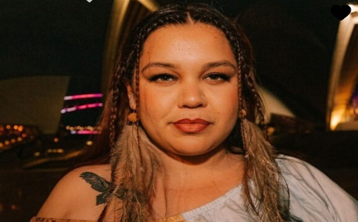  18 October, Fairfax Studio, Arts Centre. Musica Viva Australia presents Ensemble Q with William Barton, Melbourne Recital Centre, 7.00pm, 8 October.

PORT PHILLIP CITIZENS FOR RECONCILIATION
2024-2025 COMMITTEE NOMINATION FORM

For the Annual General Meeting to be held on Tuesday, 15 October 2024, 6.00pm,
Hall 3, South Melbourne Community Centre, Ferrars Place, South Melbourne.

I________________________________________________________
(Name of Proposer)

nominate__________________________________________________
(Name of Nominee)

for the Committee position of

_________________________________________________
(One of Chair, Co-Chair, Secretary, Treasurer, 3 x Ordinary members)

Signature of Proposer

______________________________________________
Name of Proposer in BLOCK CAPITALS

___________________________________________________
Signature of Seconder

_____________________________________________________
Name of Seconder in BLOCK CAPITALS

___________________________________________________

The Nominee is prepared to stand for election to this position.
Consent of Candidate: I agree to the above nomination.

Signature of Candidate:

_____________________________________________________

Please note: Proposers, Seconders and Candidates must be current, paid-up members of Port Phillip Citizens for Reconciliation. The Nomination Form must be delivered not less than 7 days before the meeting date to Rosemary Rule, PPCfR, PO Box 1446, St Kilda South, 3182, or rosemary.rule@gmail.com.

